Abdul Haseeb

20F-1066 | BSe-6a

Web Engineering Lab

lab #03

**Lab Task 01**

* **Comments in HTML:**

‘<!-- --> ‘ is used for single and multiline comments in HTML.

* **Comments in CSS:**

‘/* */’ is used for single and multiline comments in CSS.

* **Comments in JavaScript:**

In JavaScript, ‘/ /’ is used for single line comment and ‘/* */’ is used for multiline comments.

**Lab Task 02**

# **CDN Method**

<!DOCTYPE html>

<html>

<head>

    <script src=

"https://releases.jquery.com/git/jquery-git.js">

    </script>

</head>

<body>

    <h3>

        To download file, Click

        on the link below.

    </h3>

    <a id="link" href="LabTask01.html">

        Download File

    </a>

    <script>

        $(document).ready(function () {

            $("#link").click(function (e) {

                e.preventDefault();

                alert("File downloaded successfully!");

            });

        });

    </script>

</body>

</html>

# **Download Method**

<!DOCTYPE html>

<html>

<head>

    <script src= "jquery-git.js">

    </script>

</head>

<body>

    <h3>

        To download file, Click

        on the link below.

    </h3>

    <a id="link" href="LabTask01.html">

        Download File

    </a>

    <script>

        $(document).ready(function () {

            $("#link").click(function (e) {

                e.preventDefault();

                alert("File downloaded successfully!");

            });

        });

    </script>

</body>

</html>

**Lab Task 03**

<!DOCTYPE html>

<html lang="en">

<head>

<title>Lab Task 03</title>

<script src="https://releases.jquery.com/git/jquery-git.js"></script>

<script type="text/javascript">

$(document).ready(function(){

    $('#btn1').click(function(){

        $('#img').show();

    });

    $('#btn2').click(function(){

        $('#img').hide();

    });

});

</script>

</head>

<body>

<div id="img">

    <img src="liverpool.jpg" alt="Show/Hide Image" />

</div>

<button type="button" id="btn1">Show</button>

<button type="button" id="btn2">Hide</button>

</body>

</html>

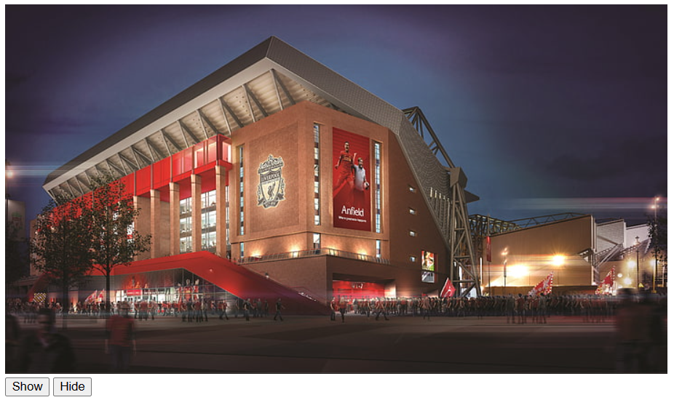

**Lab Task 04**

<!DOCTYPE html>

<html lang="en">

<head>

<meta charset="utf-8">

<title>Lab Task 04</title>

<style>

    form{

        margin: 20px 0;

    }

    form input, button{

        padding: 5px;

    }

    table{

        width: 100%;

        margin-bottom: 20px;

        border-collapse: collapse;

    }

    table, th, td{

        border: 1px solid #cdcdcd;

    }

    table th, table td{

        padding: 10px;

        text-align: left;

    }

</style>

<script src="https://releases.jquery.com/git/jquery-git.js"></script>

<script>

    $(document).ready(function(){

        $(".add-row").click(function(){

            var name = $("#name").val();

            var email = $("#email").val();

            var markup = "<tr><td><input type='checkbox' name='record'></td><td>" + name + "</td><td>" + email + "</td></tr>";

            $("table tbody").append(markup);

        });

        // Find and remove selected table rows

        $(".delete-row").click(function(){

            $("table tbody").find('input[name="record"]').each(function(){

                if($(this).is(":checked")){

                    $(this).parents("tr").remove();

                }

            });

        });

    });

</script>

</head>

<body>

    <form>

        <label> </label>

    </form>

    <table>

        <thead>

            <tr>

                <th>Select</th>

                <th>Name</th>

                <th>Email</th>

            </tr>

        </thead>

        <tbody>

            <tr>

                <td><input type="checkbox" name="record"></td>

                <td>Abdul Haseeb</td>

                <td>abdulhaseeb12567@mail.com</td>

            </tr>

            <tr>

                <td><input type="checkbox" name="record"></td>

                <td>Muntazar Shah</td>

                <td>shahjee123@gmail.com</td>

            </tr>

            <tr>

                <td><input type="checkbox" name="record"></td>

                <td>Ahmed</td>

                <td>ahmed123@gmail.com</td>

            </tr>

        </tbody>

    </table>

    <button type="button" class="delete-row">Delete Row</button>

</body>

</html>

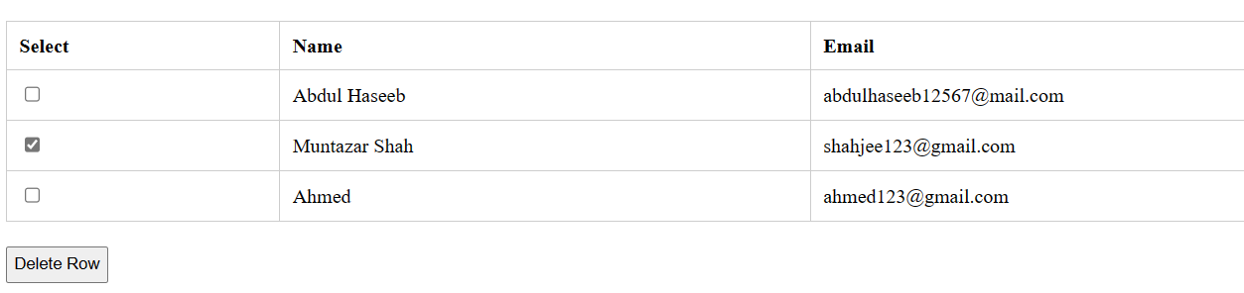

**Lab Task 05**

<!DOCTYPE html>

<html lang="en">

<head>

<meta charset="utf-8">

<title>Lab Task 05</title>

<script src="https://releases.jquery.com/git/jquery-git.js"></script>

<script>

$(document).on("click", function(event){

    alert( event.target.className +"  ID: " + event.target.id);

})

</script>

</head>

<body>

    <button type="button" class="Name Class" id="1234">Name </button>

    <button type="button" class="Roll No Class" id="7843"> Roll No</button>

    <button type="button" class="Email Class" id="8743">Email</button>

</body>

</html>

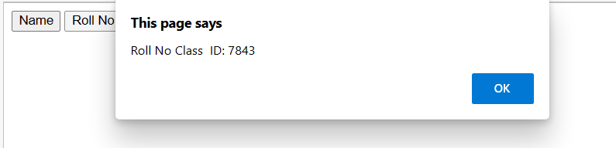

**Lab Task 06**

<!DOCTYPE html>

<html>

<head>

<style>

p {

padding-top: 50px;

padding-right: 30px;

padding-bottom: 50px;

padding-left: 80px;

}

</style>

<script src="https://code.jquery.com/jquery-git.js"></script>

<meta charset="utf-8">

<meta name="viewport" content="width=device-width">

<title>Lab Task 06

title>

</head>

<body>

<p id="myText">jQuery Exercises, Practice, Solution</p>

<script>

$("p").click(function() {

   var Class = $("#myText").outerWidth();

   alert("Width + padding + borders : " + Class);

});

</script>

</body>

</html>

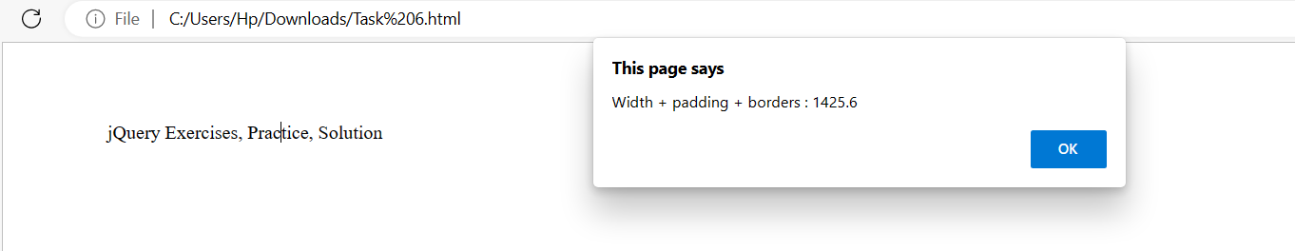

**Lab Task 07**

<!DOCTYPE html>

<html>

<head>

<script src="https://releases.jquery.com/git/jquery-git.js"></script>

<meta charset="utf-8">

<meta name="viewport" content="width=device-width">

<title>Lab Task 07 </title>

</head>

<body>

<div id="selected">

<p>Black</p>

<p>Purple</p>

<p>Red</p>

<p>Pale Blue</p>

<p>Yellow</p>

<p>Green</p>

</div>

<script>

$("p").click(function() {

var count = $("#selected p").length;

   alert("Total labela in the code are: " + count);

});

</script>

</body>

</html>

**Lab Task 08**

<!DOCTYPE html>

<html>

<head>

<style>

div {

    position: absolute;

    background-color:

#76c55e;

    left: 40px;

    width: 180px;

    height: 180px;

    margin: 5px;

  }

</style>

<script src="https://releases.jquery.com/git/jquery-git.js"></script>

<meta charset="utf-8">

<meta name="viewport" content="width=device-width">

<title>Lab Task 08</title>

</head>

<body>

<button id="left">Move Left</button>

<button id="right">Move Right</button>

<div class="block"></div>

<script>

$("button").click(function() {

 $( "#right" ).click(function() {

  $( ".block" ).animate({ "left": "+=150px" },8000);

});

$( "#left" ).click(function(){

  $( ".block" ).animate({ "left": "-=150px" },8000);

});

});

</script>

</body>

</html>

